**Report for NASA Director Gene Kranz By-Arpit Agarwal**

I. Introduction

This report provides an analysis of the gravitational potential and forces experienced by the Apollo missions, as well as the performance of the Saturn V rocket. The calculations and plots presented here aim to support NASA's funding for the Apollo program by quantifying the mission's physics and rocket performance.

II. The Gravitational Potential of the Earth

The gravitational potential of the Earth was calculated and visualized using a 1D plot and a 2D color-mesh plot. These plots show how the potential varies with distance from the Earth.

Figure 1: 1D Plot of Gravitational Potential vs. Distance from Earth  
This plot shows the absolute value of the gravitational potential as a function of distance from the Earth's surface. The y-axis is logarithmic to highlight the rapid decrease in potential with distance.

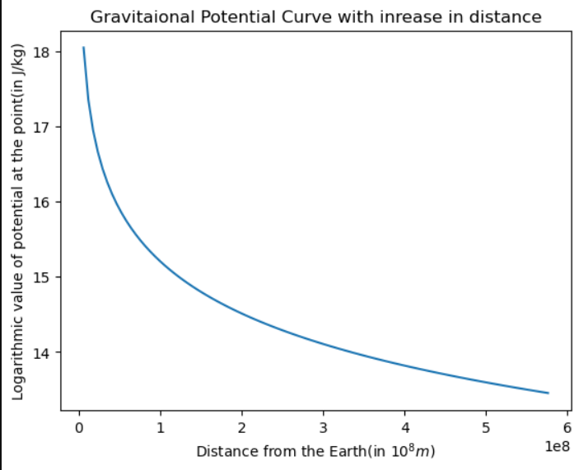

Figure 2: 2D Color-Mesh Plot of Gravitational Potential of the Earth  
This plot illustrates the gravitational potential density around the Earth, with the Earth at the origin. The color bar represents the logarithmic potential density, showing how the potential decreases with distance.

III. The Gravitational Potential of the Earth-Moon System

To account for the Moon's influence, we updated our model to include both the Earth and Moon.

Figure 3: 2D Color-Mesh Plot of Gravitational Potential of the Earth-Moon System  
This plot shows the combined gravitational potential density of the Earth-Moon system. The Earth is at the origin, and the Moon is positioned at a distance of approximately 384,000 kilometers. The color bar represents the logarithmic potential density.

Figure 4: 2D Contour Plot of Gravitational Potential of the Earth-Moon System  
This contour plot provides additional insight into the potential distribution, with contours spaced to avoid bunching around the Earth and Moon. This helps visualize the equipotential lines around these celestial bodies.

IV. The Gravitational Force Field of the Earth-Moon System

A 2D streamplot was used to visualize the gravitational force field exerted by the Earth-Moon system on the Apollo command module.

Figure 5: 2D Streamplot of Gravitational Force Field  
This streamplot illustrates the gravitational force vectors across the Earth-Moon system. The colors represent the magnitude of the forces, providing a visual understanding of how the Apollo spacecraft navigates through this gravitational landscape.

V. Projected Performance of the Saturn V Stage 1

Calculations for the Saturn V rocket's performance included determining the burn time and altitude at burnout. The burn time was found to be approximately 157.69 seconds, and the altitude at burnout was about 74,093.98 meters.

Comparison with Test Results:

* The calculated burn time is slightly less than the test result of about 160 seconds.
* The calculated altitude is higher than the test result of about 70 km, likely due to neglecting atmospheric drag in our model.

VI. Discussion and Future Work

Our calculations provide a basic understanding of the gravitational environment and rocket performance. However, they simplify several factors, such as neglecting atmospheric drag, which can significantly affect the rocket's actual performance. Future work should include more realistic models incorporating these factors to improve accuracy.

The discrepancies between calculated and test results can be attributed to simplifications in our model. Including drag forces and other environmental factors will enhance the model's accuracy and provide a more comprehensive understanding of the mission's dynamics.